Lab 3

Q1)
a)
Variables: Start time of {$T_{1}, T_{2}, T_{3}, T_{4}, T_{5}\}$
Domain: D = {1pm, 2pm, 3pm}
Constraints:
Implicit: $T_{i} ≠ T_{j}$
Explicit:
- $T_{1}>T_{4}$
- $T_{2}<T_{5}$
- $T_{2}<T_{3}$
- $T_{3}≠T_{1}$
- $T_{3}≠T_{5}$
- $T_{5}≠2$
b)
Constrain graph
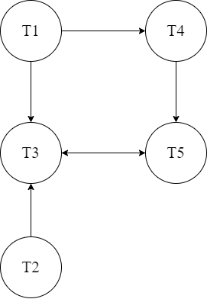

Q2)
AC-3 Execution
Iteration 1:
- Queue: {(a,b),(b,a),(b,c),(c,b),(c,d),(d,c)}
- (u,v) removed: (a,b)
- Revise ($γ$,a,b):
  - $\left|a-b^{2}\right|≤1$
  - For each $a∈D_{a}$, check if there is a $b∈D_{b}$ such that $\left|a-b^{2}\right|≤1$
  - After revision, $D_{a}=\{1,2,3,4,5\}$ (since 1,4,9 are the squares, and only these $a$ values can be within 1 of these squares).
- New pairs added: {(a,b)} (no new pairs added because all variables connected to $a$ are already in the queue)
Iteration 2:
- Queue: {(b,a),(b,c),(c,b),(c,d),(d,c)}
- (u,v) removed: (b,a)
- Revise ($γ$,b,a):
  - $\left|a-b^{2}\right|≤1$
  - For each $b∈D_{b}$check if there is an $a∈D_{a}$such that $\left|a-b^{2}\right|≤1$
  - After revision, $D_{b}=\{1,2,3\}$ (only $b=1,2,3$ are such that $b^{2}∈\left\{1,4,9\right\}$ within 1 of the revised $D_{a}$)
- New pairs added: {(a,b),(b,c)} (no new pairs added because all variables connect to $b$ are already in the queue)
Iteration 3:
- Queue: {(b,c),(c, b),(c,d),(d,c)}
- (u,v) removed: (b,c)
- Revise ($γ$,b,c):
  - $b≤c-7$
  - For each $b∈D_{b}$, checking if there is a $c∈D_{C}$ such that $b≤c-7$
  - After revision, $D_{b}=\{1,2,3\}$ (no changes needed because all $b$ values have corresponding $c$ values in the domain)
- New pair added: {(a,b)} (no pair added because all variables connected to $b$ are already in the queue)
Iteration 4:
- Queue: {(c,b),(c,d),(d,c)}
- (u,v) removed: (c,d)
- Revise ($γ,c,b)$:
  - $b≤c-7$
  - For each $c∈D_{C}$, checking if there is a $b∈D_{b}$ such that $b≤c-7$
  - After revision, $D_{C}=\{8,9,10\}$ (since $b$ in {1,2,3} means $c≥b+7$)
- New pairs added: {(b,c)} (no new pairs added because all variables connected to c are already in the queue)
Iteration 5:
- Queue: {(c,d),(d,c)}
- (u,v) removed: (c,d)
- Revise ($γ,c,d$):
  - $c<d-1$
  - For each $c∈D_{c}$, checking if there is a $d∈D_{d}$ such that $c<d-1$
  - After revision, $D_{d}=\{9,10\}$ (since $c∈\{8,9,10\}$ means $d≥c+2$)
- New pairs added: {(c,d)} (no pairs added because all variables connected to d are already in the queue)
Iteration 6:
- Queue: {(d,c)}
- (u,v) removed: (d,c)
- Revise ($γ,d,c)$:
  - $c<d-1$
  - For each $d∈D_{d}$, checking if there is a $c∈D_{c}$ such that $c<d-1$
  - After revision, $D_{d}=\left\{9, 10\right\}$ (no change needed because all d values have corresponding c in the queue)
- New pairs added: {(d,c)} (no pairs added because all variables connected to d are already in the queue)
Final Domains
- $D_{a}=\{1,2,3,4,5\}$
- $D_{b}=\{1,2,3\}$
- $D_{c}=\{8,9,10\}$
- $D_{d}=\left\{9,10\right\}$

Q3)
View Codes in the codes folder submitted along with this document.

4)
1. Concept
- Books
- Author
- Library Member
2. Properties
Book
- Title (string): the title of the book.
- ISBN (string): the International Standard Book Number of the book.
- Publication Date (date): the date the book was published.
- Authors (list of authors): The authors who wrote the book.
Author
- Name (string): the name of the author.
- Birthdate(date): the birthdate of the author.
- Books Written (list of Book): The books that the author has written.
Library Member
- Name (string): the name of the library member.
- Library Card Number (string): the unique number associated with the library member’s card.
- Borrowed Books (list of Book): the books that the library member has borrowed.
3. Relationships
- Wrote (Author -> Book): Relationship between Author and Book. An author can write multiple books, and a book can have multiple authors.
- Borrowed By (Library Member -> Book): Relationship between Library Member and Book. A library member can borrow multiple books, and a book can be borrowed by multiple library members over time.

Q5)
Neo4J Example Guide
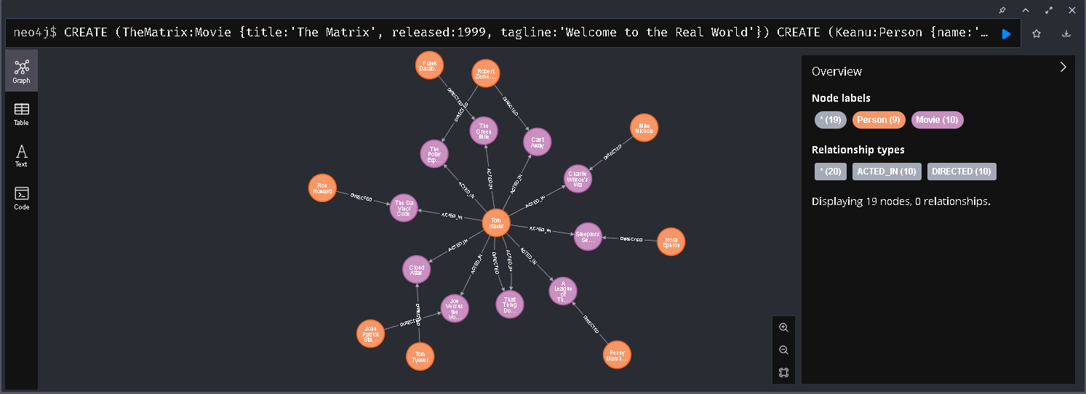
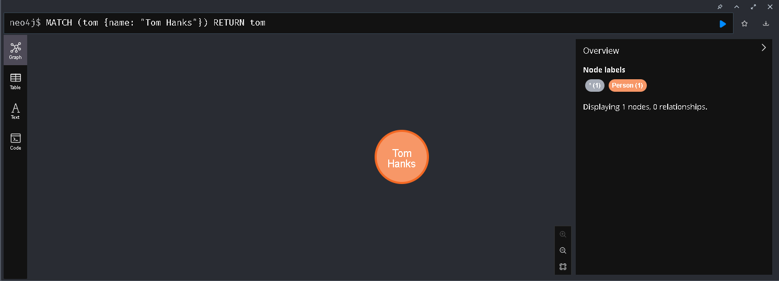
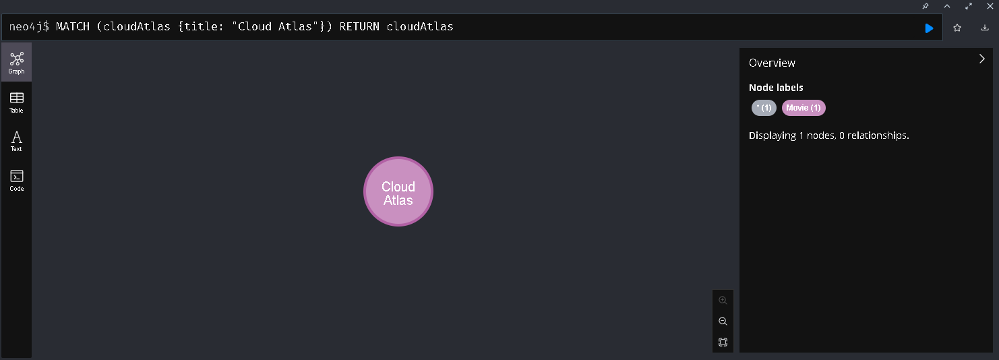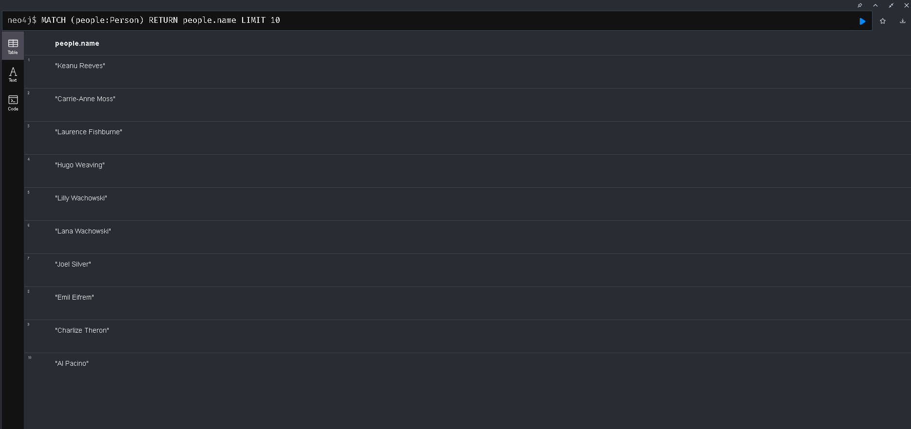
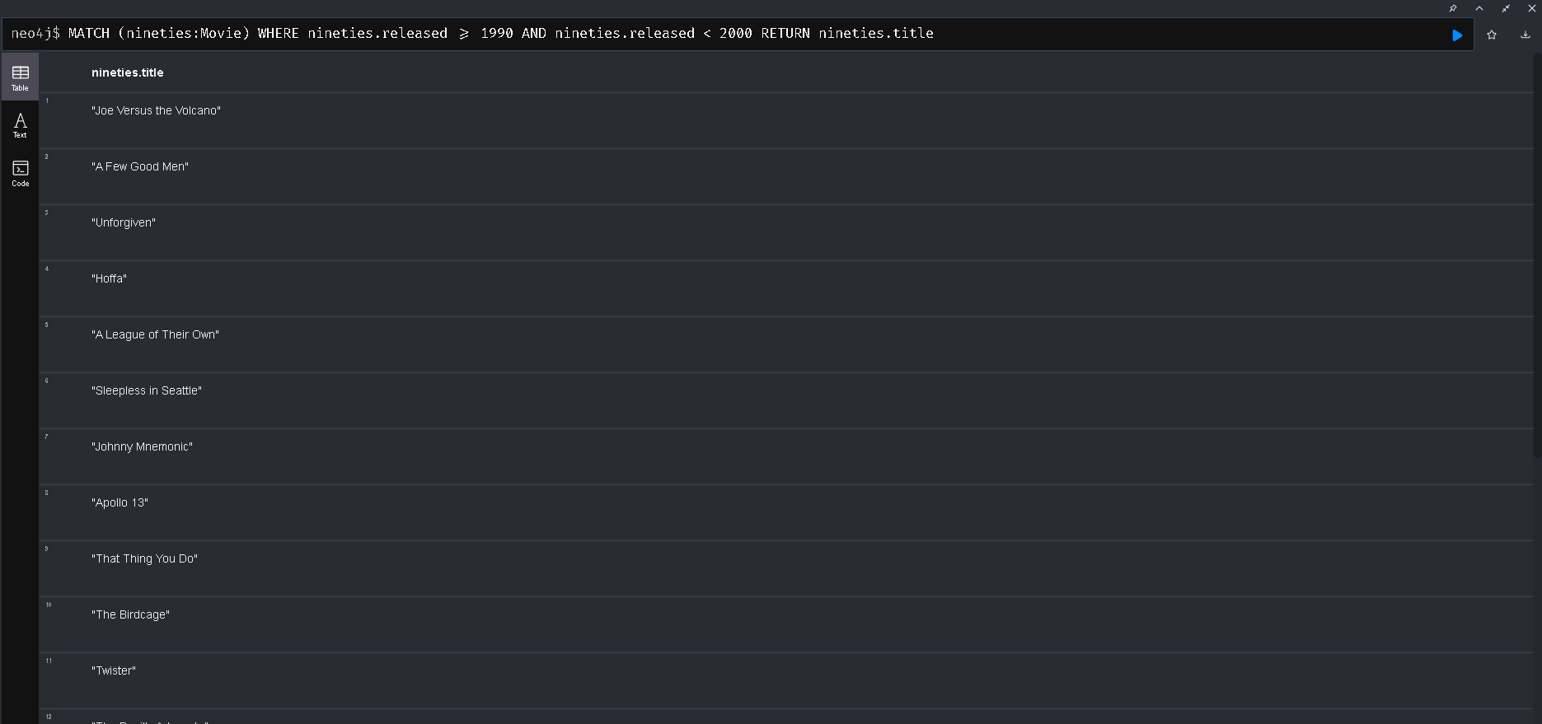
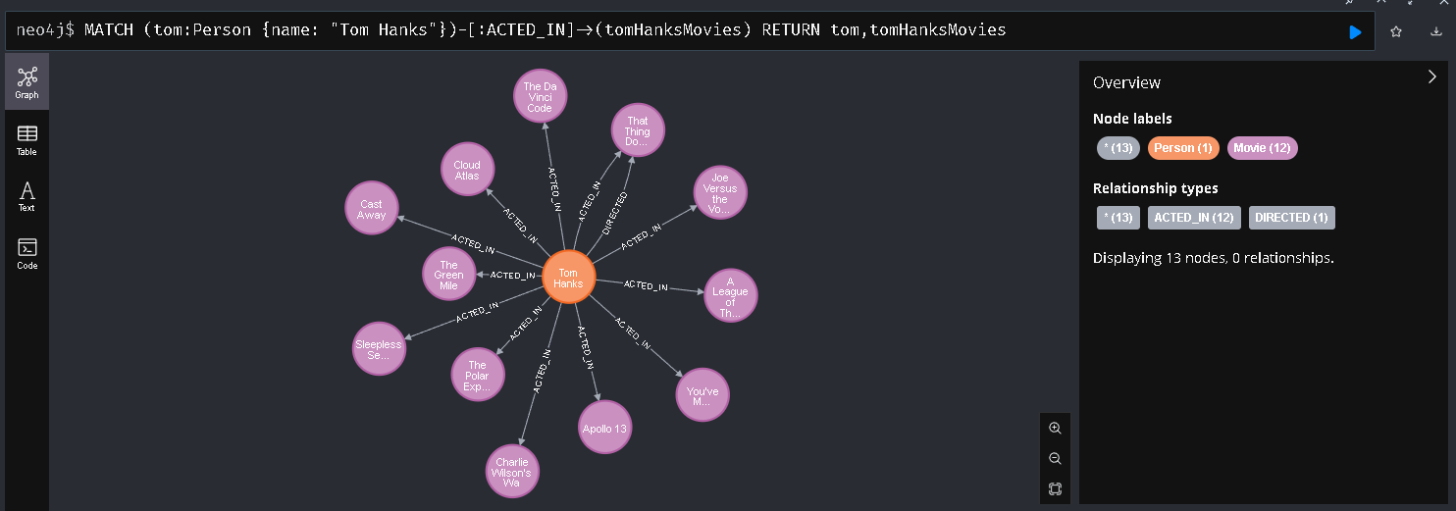
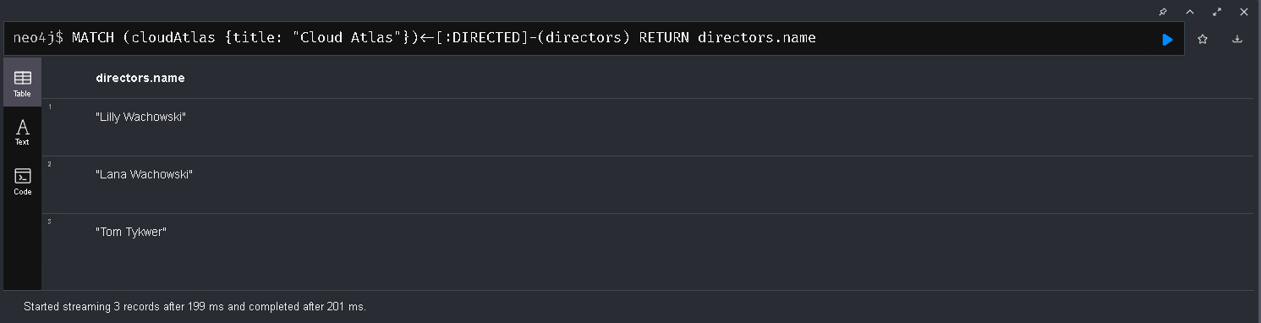
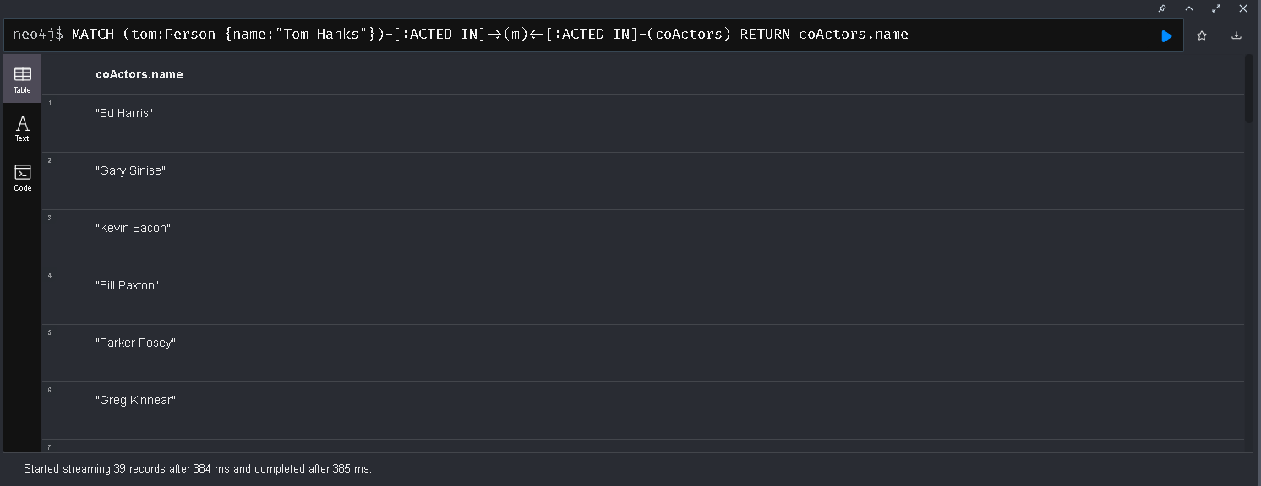
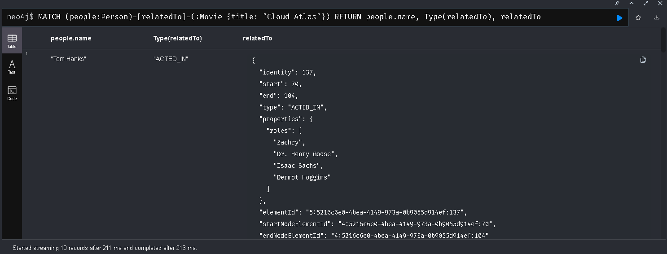
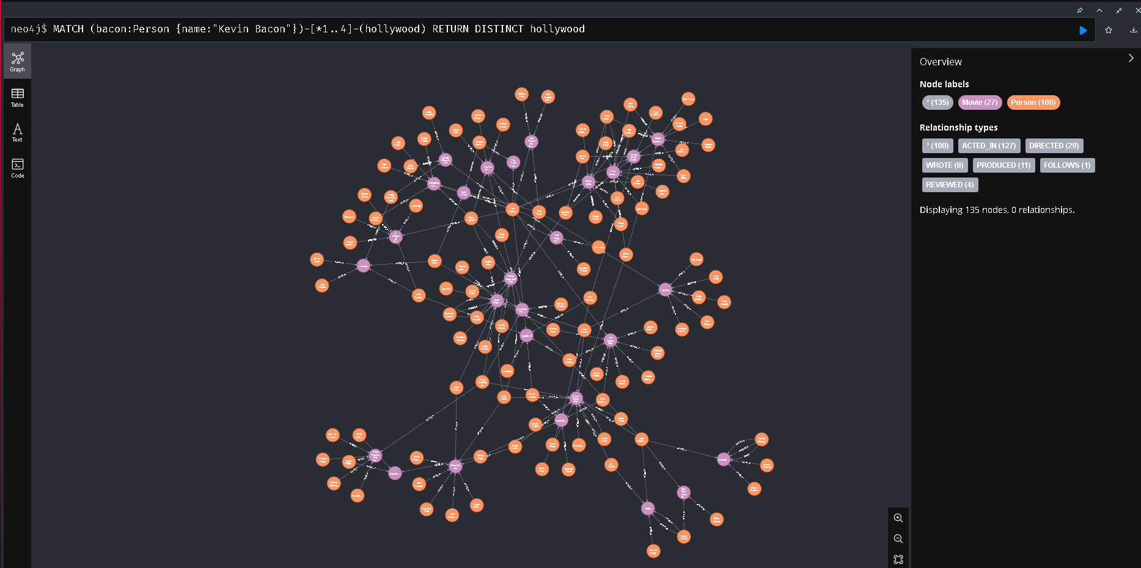
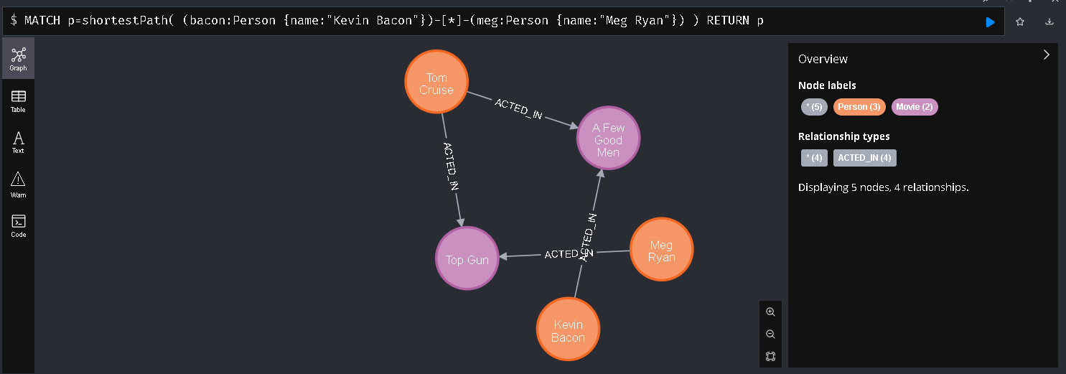
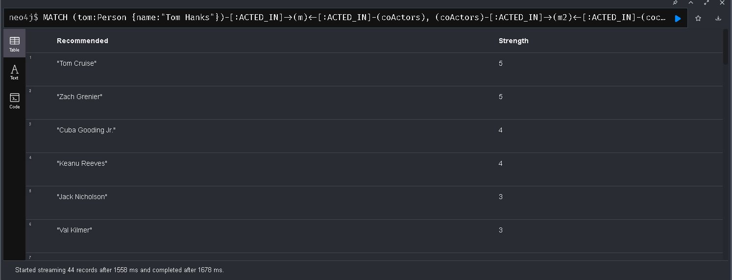
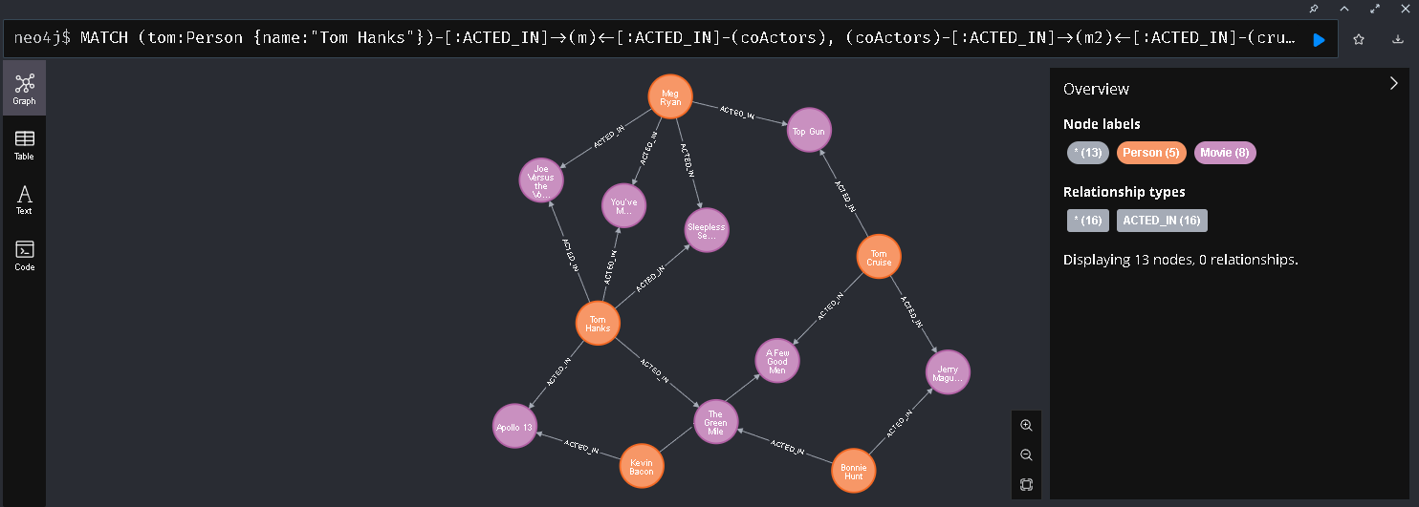
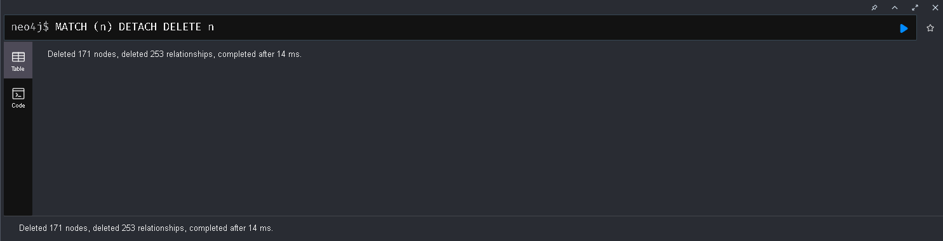
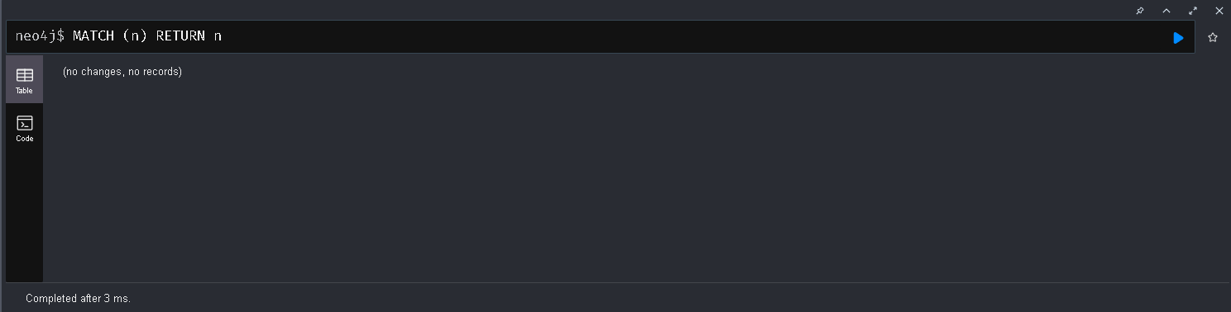

Cypher Tutorial
